Steam Happens 5 - A clutch for your boat

Why bother with an engine clutch?

In 1990 I was working in Wiesbaden, Germany. As good luck would have it, I had just found a Rose hull and a used Reliable engine and boiler through Dave Thompson in New Hampshire and was starting to assemble my boat during my annual summer leave in Maine. Meanwhile, in Germany I had met Helmut Strothjohann, skipper of the Vaporosa, a pretty Elliott Bay hull with a Semple V compound and fire tube boiler.

The Vaporosa was a well-configured boat with a few interesting design tweaks. Helmut (right photo) had wide-ranging experience in live steam, running from full-scale locomotives to models and boats. I’ve always found it very worthwhile to “hang around” more knowledgeable steam enthusiasts and, as expected, my experiences with Helmut proved invaluable to providing ideas for setting up my own boat.

As I approached the dock for my first ride on the Vaporosa I noticed that the engine was slowly ticking over. I also noted that there was no strain on the lines and no prop wash. I didn’t think too much about it at the time. After an exciting Rhine rundfahrt we tied up at the dock. Helmut fiddled with the prop shaft for a second and “lo and behold” the prop disengaged. The engine then ticked over to keep the boiler at level with just a half atmosphere of pressure (about 7 PSI). Helmut informed me that he had modified a German water pump clutch to use on his prop shaft. He said that it was very handy and advised me to put one on my boat. Unfortunately, at the time I was uncertain of the value of a clutch and, consequently, I left Germany without a water pump clutch mechanism in my luggage.

I have been running my boat, “A Boy’s Will,” without a clutch for about 13 years and little by little I have been convinced that Helmut was correct, a clutch is very handy. A few of my reasons follow:

I often have to beach my boat and have occasionally been embarrassed by the plume of mud-stained wash (and consequent bottom erosion) produced as I turn the engine to keep the boiler filled. I can now beach the boat, let the pressure drop and still keep the boiler water level and the engine warmed. When tied up at the dock awaiting passengers I no longer need to keep 15 psi in the boiler to keep things at the ready. By disengaging the clutch I can keep the boiler and the engine warm and supple with a very small fire and only 5 psi or so on tap. No strain on the lines, no prop wash. The clutch also turns out to be very beneficial when demonstrating how the engine works to dockside observers and when the boat is on the trailer at an exhibit, no spinning prop danger and very low boiler pressure (as required in many live steam exhibits).

How my clutch mechanism works:

The right CV joint:

As a junk collector, I had an old Mitsubishi CV jointed half shaft in my garage left over from an old car repair. I have always preferred a propshaft CV joint to a pair of universals because you only need one joint to connect your engine to the prop. I also like to keep my engine aligned horizontally rather than in direct line with the prop shaft. However, I had initially put universal joints on my boat because you can buy universal yokes in any combination of sizes so that no machining was required to connect my 7/8” engine shaft to the 1” prop shaft. At the time I first put the boat together I had no machine tools and couldn’t do any serious modifications.

I disassembled the Mitsubishi joint and found parts much like those shown in this Rzeppa CV joint diagram. After a little thought, I realized that the joint could be modified to become a clutch/CV combo. By the way, the CV joint I used was an inboard, “cross groove” type not an outboard Rzeppa-type joint. The cross-groove-type joint allows the race and cage mechanism to slide back and forth along the entire inner length of the housing. This sliding ability and long housing is essential to our clutch design

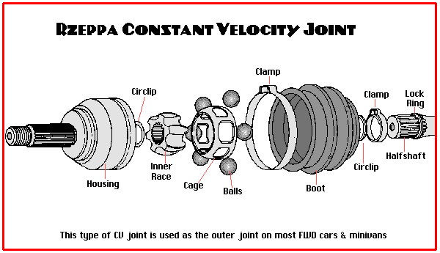

The cross-groove joint looks almost exactly like the Rzeppa above except that the external shape of the housing is more cylindrical and proportionately longer (or deeper) than the housing shown above. The internal grooves run the entire length of the inner housing as seen in the photo below.

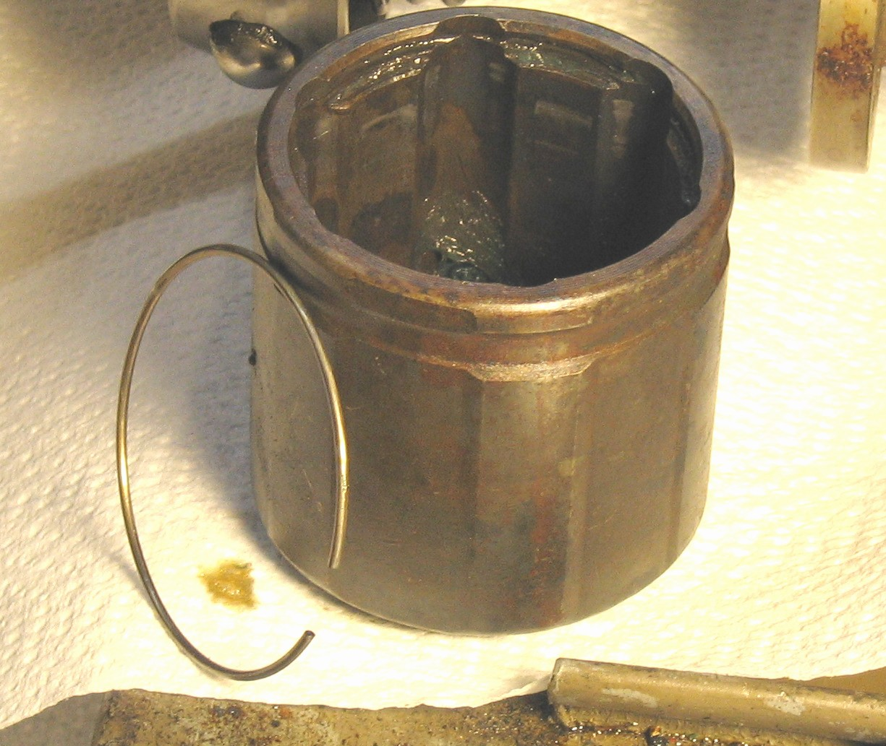

When hunting for an appropriate CV half shaft, it may be best to find one with as long and externally cylindrical a “cross-groove” housing as possible. I think many Chrysler, Mazda, Nissan, Fords (with Mazda components) and Subaru parts fit the bill. The Mitsubishi housing is about 3 inches long. Since it’s the external or Rzeppa CV joint that often fails, you can usually dumpster dive a half shaft with a perfectly good inboard joint and boot in the junk bin of many garages. Ask your local mechanic. Don’t buy one!

Converting the CV joint into a clutch:

The photo below shows the CV joint clutch disengaged. It is locked into this position via the brass-handled pin.

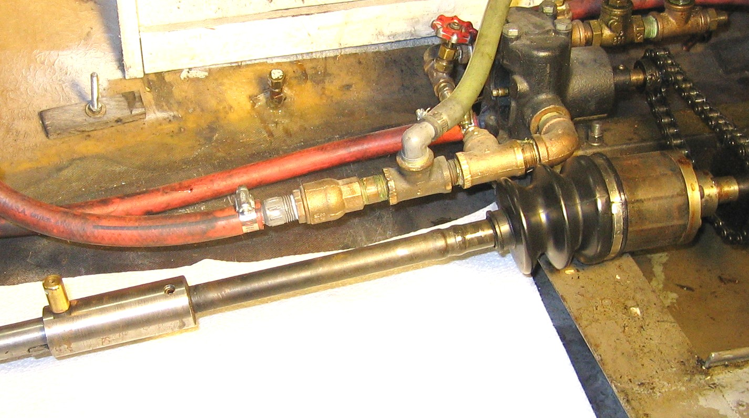
The idea behind the clutch is to allow the CV joint’s male spline to slide in and out of the female spline of the inner race, thus engaging and disengaging the inner race splines. In order to do so:

- The CV’s halfshaft must be able to slide rearwards on the propshaft via a keyed collar and lock the half shaft rearwards into the disengaged position (in my case using a brass handled pin to detent the hole seen on the top of the prop shaft in the left photo).

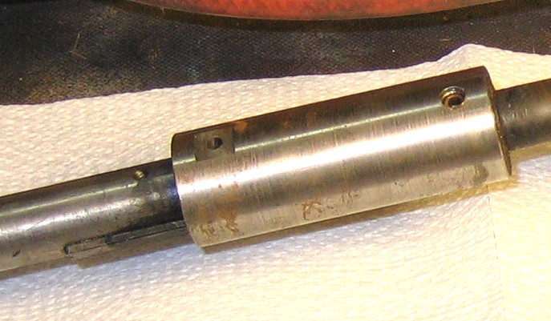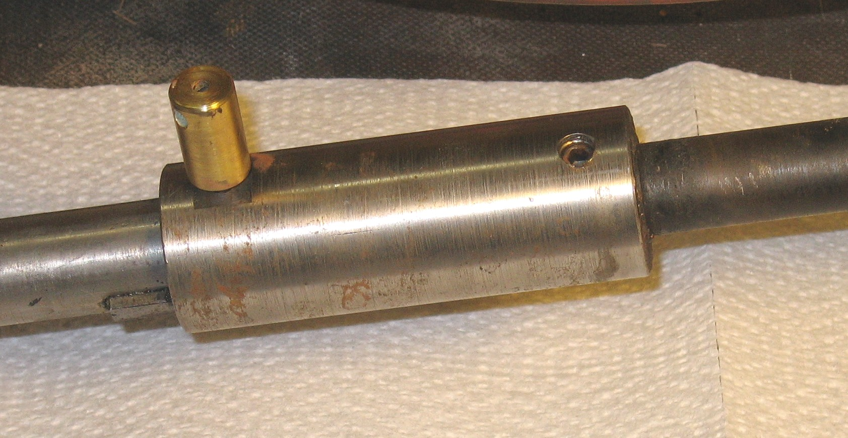

Note that what remains of the outboard end of the CV halfshaft (the right shaft in each photo above) is fixed to a keywayed collar via a setscrew (the collar is later silver soldered to the half shaft, once adjusted). This collar is about 4.25 inches long. Since it’s always keyed, the collar is always rotationally engaged. When the clutch is engaged the pin is removed and the collar is slid forward as in the left photo. When engaged, there is a gap the length of the CV spline between the shafts inside the collar. The collar is long enough to allow the CV halfshaft to slide fore and aft about an inch. This allows the splines of the inner race of the CV joint to slide out of engagement. Warning: we found it difficult to broach a keyway 4.25 inches long. It’s best to leave this job to an experienced machinist with a really good press and an extra-long, sharp broach.

- There must be a means of keeping the male halfshaft spline in alignment with the inner race’s female spline once the clutch has been disengaged by withdrawing the male spline from the CV inner race. This is accomplished via a ball bearing fitted, rotating “alignment cylinder” whose diameter is sized to the minimum diameter of the spline. The cylinder length is 2 times the length of the spline The rotating alignment cylinder is attached to the forward end of the male spline via a ¼ inch threaded rod. Since the spline was initially hardened, heating it to the appropriate redness and allowing it to slowly cool in a bucket of dry wood ash annealed it. The splined end was then drilled and tapped ¼-20 to a depth of about 1.25 inch. Since these half shafts were originally designed to deliver about 115 horsepower to the auto wheel I did not feel that they needed to be rehardened. There was no detectable wear on the cylinder after a full season’s use. A photo of the alignment cylinder mounted on the fore end of the halfshaft is shown below.

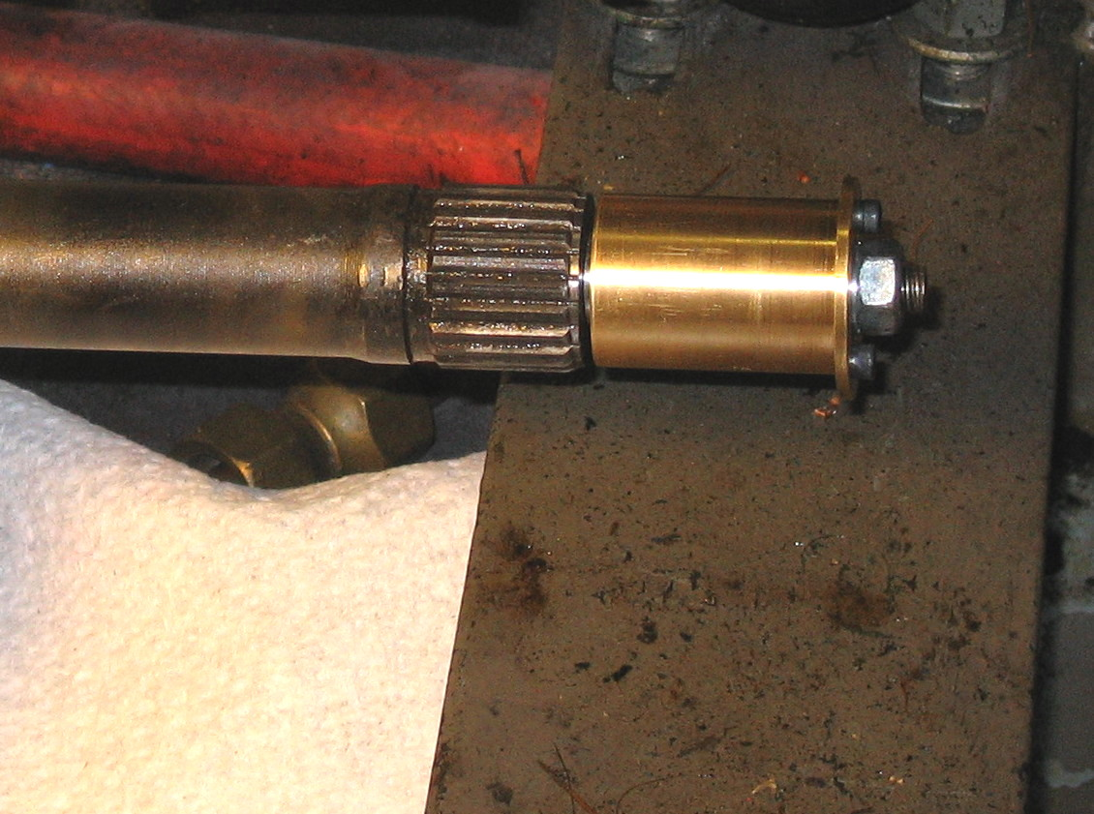

In the photos below you can see the CV race shifted from the meshed splines onto the alignment cylinder.

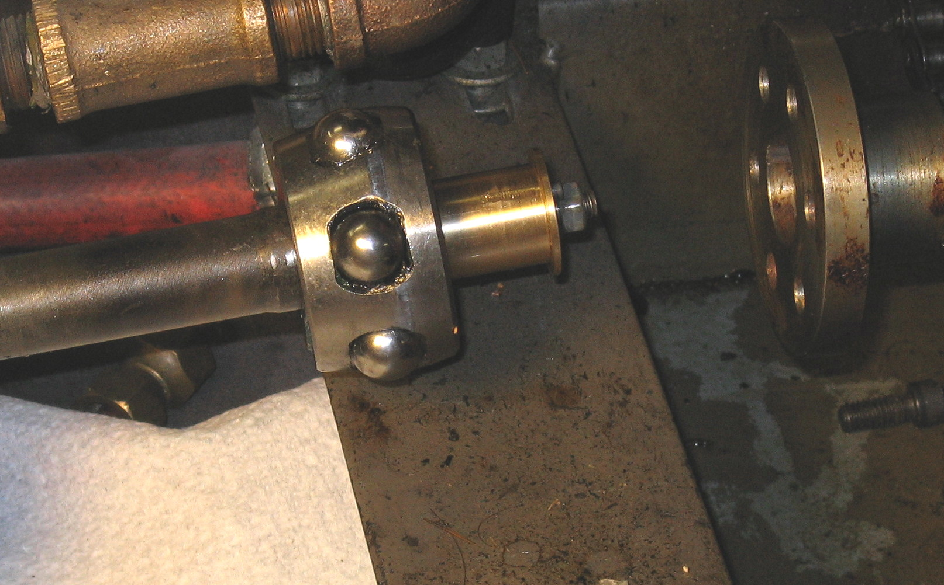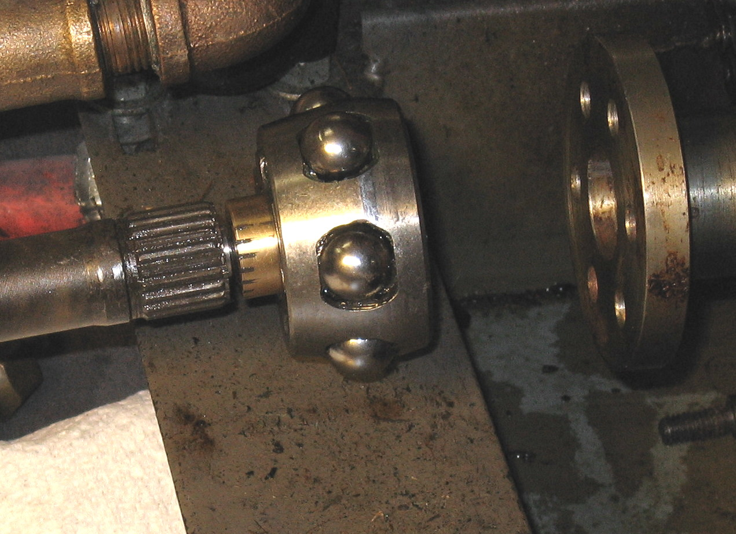

The alignment cylinder is the secret to maintaining alignment of the withdrawn male and female splines. So here’s a few photos showing its construction.

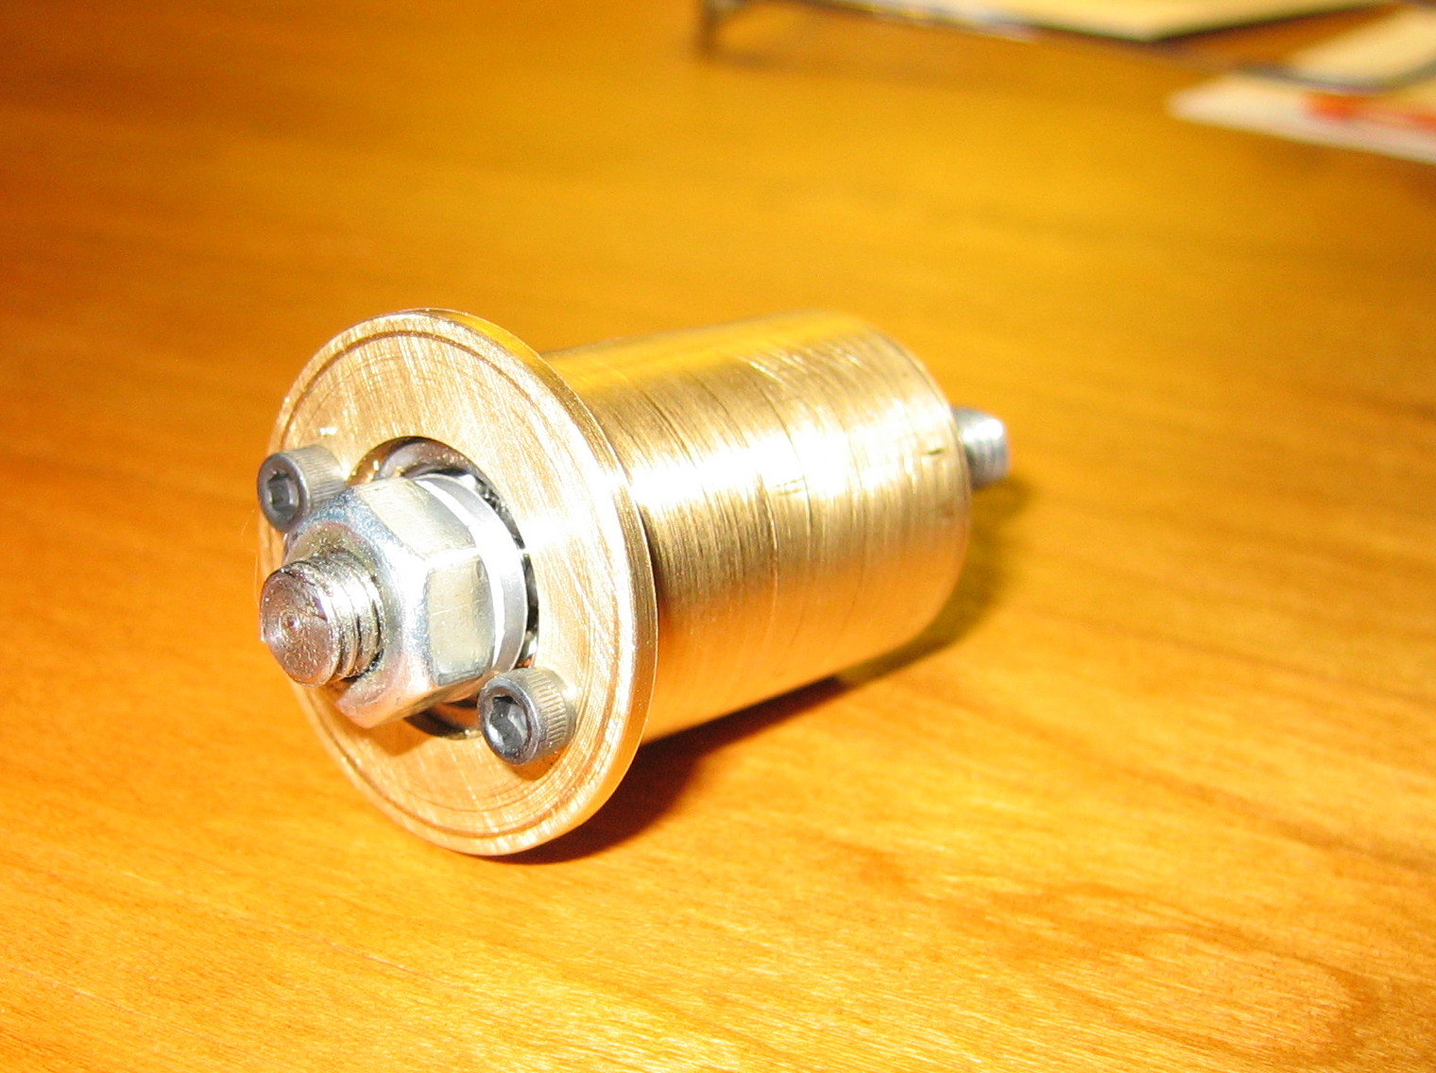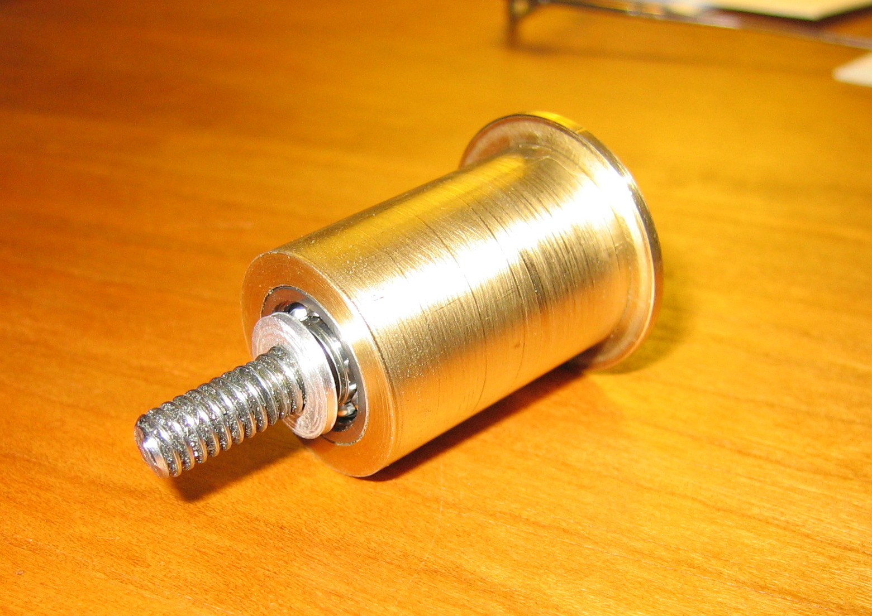

and the alignment cylinder parts disassembled

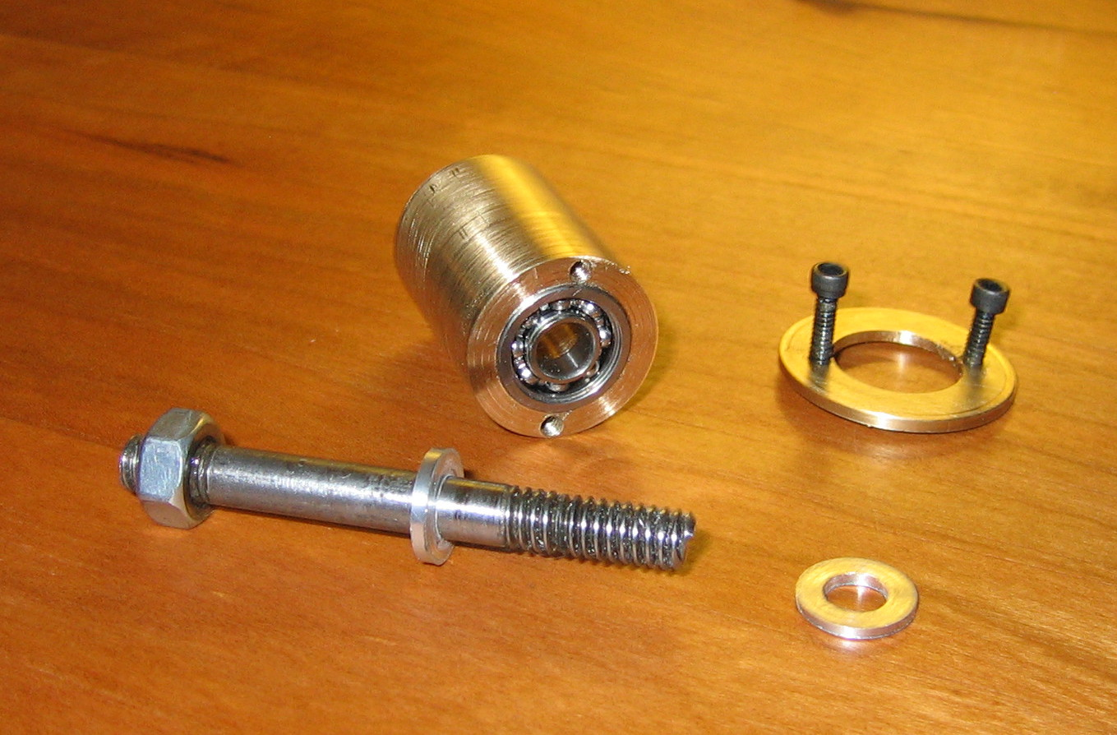

Since my design was evolutionary, the brass re-taining flange in the above photos could have been machined as a single piece with the cylinder. The retaining flange is needed to retain a very weak spring used to keep about 3 lbs of tension on the disengaged halfshaft. This tension assists the engagement process and the continual engagement of the splines. Here’s a photo of the whole alignment assembly with the housing removed. The spring is shown in place. Note that the spring is about 1.25 inches long, just long enough to keep some tension on the brass-handled disengagement pin and cause partial re-engagement of the splines once the disengagement pin is released.

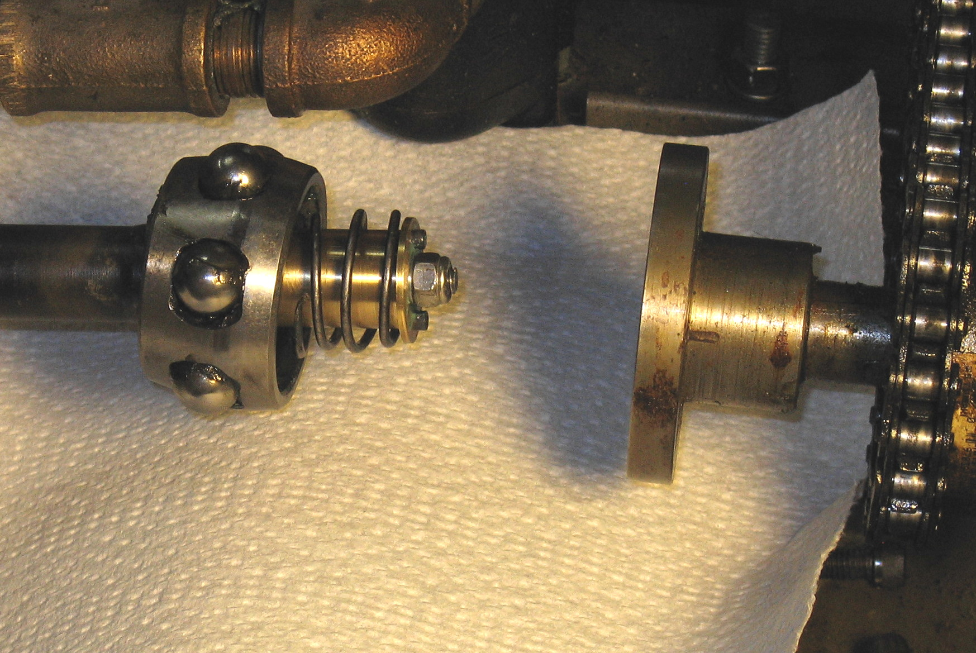

Ball bearings are used in the alignment cylinder because it is always rotating whether the clutch is engaged or not. Disengaged, the CV race is on the alignment cylinder and both will continue to rotate with the engine while the halfshaft and propshaft are idle. The cylinder was fitted at both ends with open ball bearings whose inner diameter was ¼ inch and whose OD was 5/8” (McMaster-Carr # 60355K13). These are packed with wheel bearing grease at assembly. Note that two spacer washers used at either end of the alignment cylinder support only the inner races of both ball bearings, keeping it freely rotating. A nylon collar nut is used to adjust the bearing preload or bearing rolling resistance. The ¼ inch rod was threaded 1/4 –20 for 1.25 inch on the end inserted into the halfshaft and ½ inch on the other end.

The clutch has the following additional parts (from engine to propshaft):

- A flange (seen in the right side of the previous photo), designed to connect the engine shaft to the fore end of the CV housing. Our was fabricated, but a commercial flange is probably available at your local farm equipment supplier. The flange is attached to the engine shaft via a setscrew and a Woodruff key, thus allowing adjustment and locking of the flange position on the shaft.

- The CV housing was originally hardened and required annealing to prepare it for machining. A pass with a file will tell you if it’s sufficiently softened for machining. The housing’s shaft and spline was then machined down to a slight boss sized to my 7/8 inch diameter engine shaft. This allows the housing to fit onto the flange with no alignment problems. I did not re-harden the housing and as it is grease packed, it showed absolutely no sign of wear after a hard summer’s use.

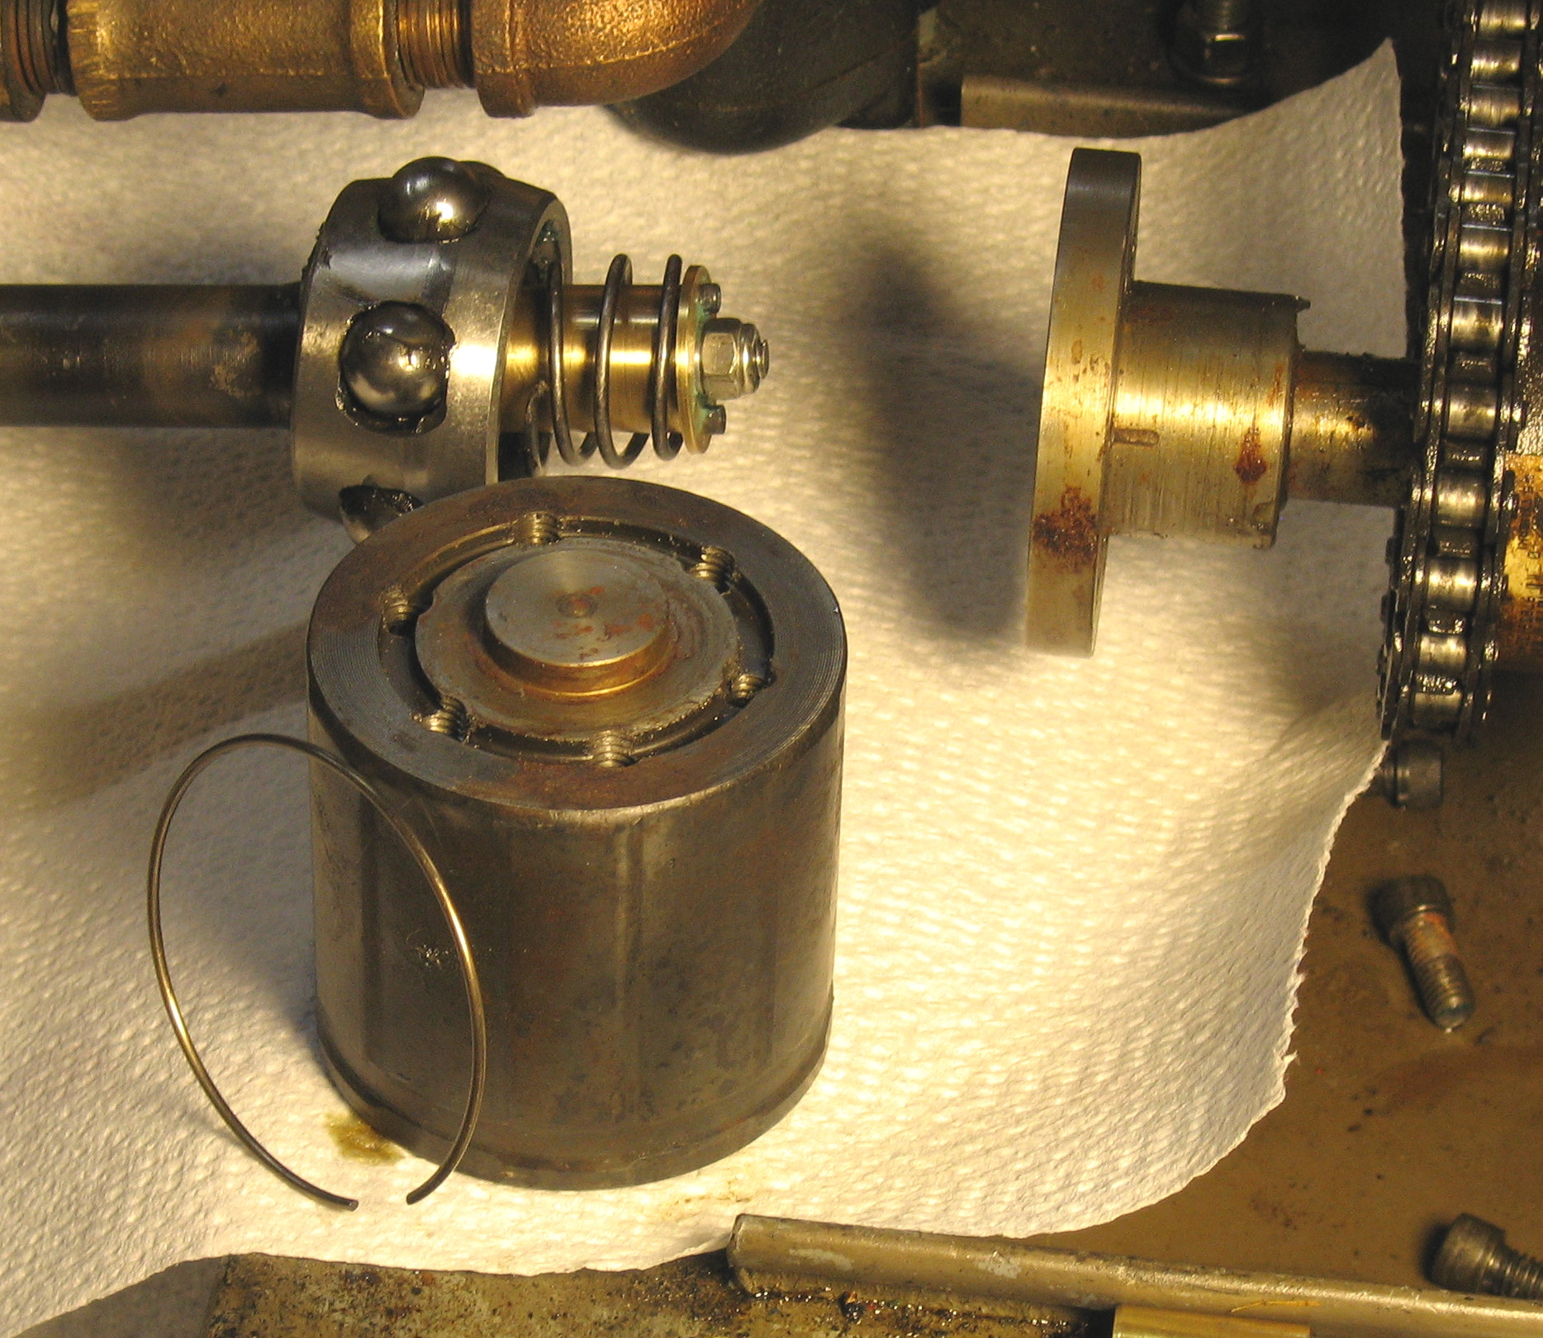
- The CV housing is tapped and the flange drilled with from 4 to 6 holes to allow the housing to be fastened to the flange.The CV housing was then mounted on the flange and bolted.

Here’s a picture of the clutch engaged (boot off). Note that the wire retaining clip is inserted. This functions to help keep the CV race in the housing during the disengagement. As you disengage the clutch it must contact the retaining clip in order to allow the male spline to slide out (rearwards). It may look fragile, but it is more than adequate to do the job.

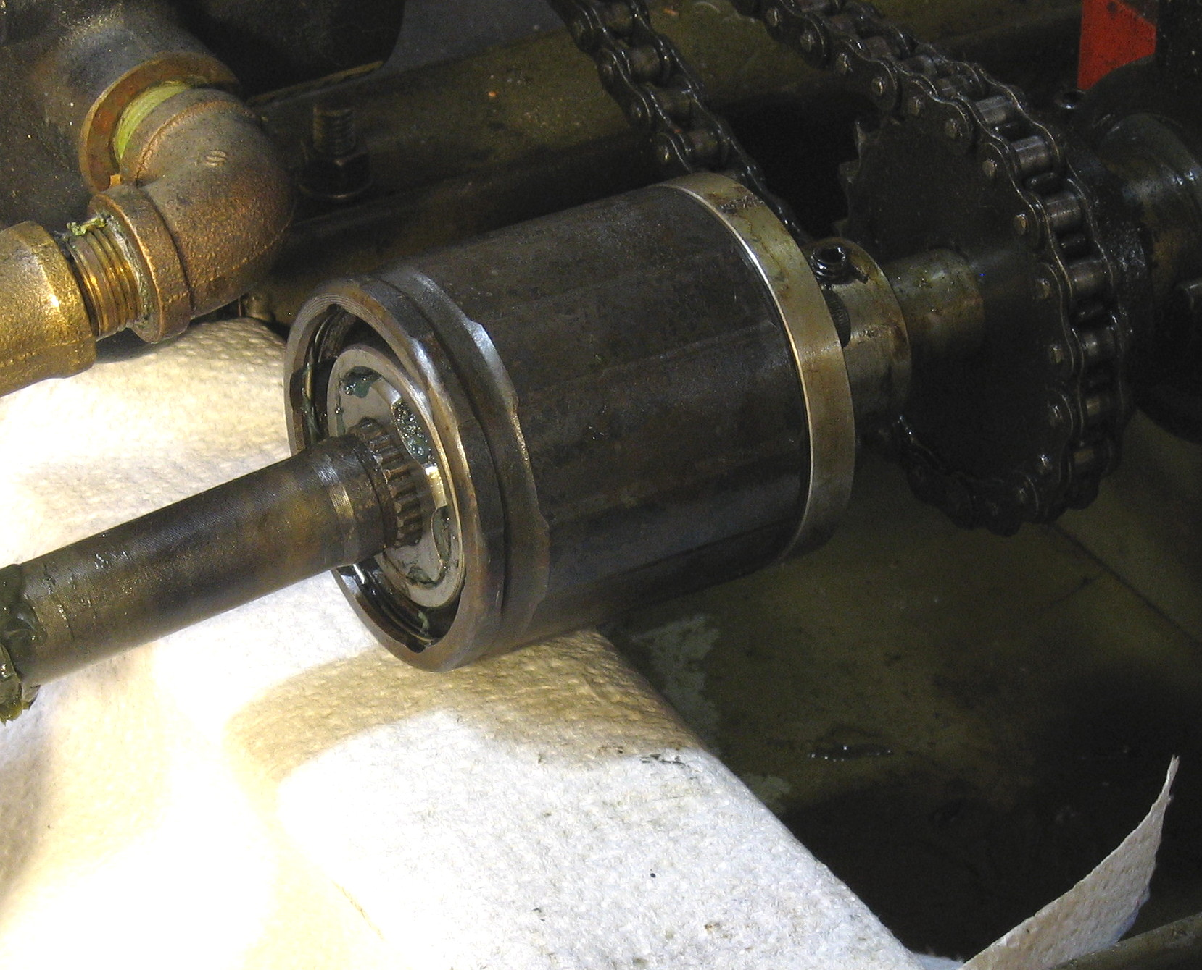

- Note that the rubber boot is attached only on the housing end. The aft, smaller boot retaining band or clamp is not used so that the half shaft may be idle while the housing rotates during disengagement.

Fitting the modified CV joint to your boat.

The hardest part of the process was cutting the halfshaft the correct length. By the way, our shaft was hardened throughout so that the shaft needed to be annealed where it was to be cut.

Here’s a way to determine the correct length of the halfshaft. Find a hardwood dowel a bit smaller in diameter than the halfshaft. Place the flange on the engine and lock the setscrew down halfway along the woodruff key. Then bolt the CV housing to the engine flange and Move the CV assembly (the cage, balls and inner race) to the aft part of the housing so that it contacts the wire retaining clip. This is where the CV assembly will be when you begin disengagement. Then place the dowel in the female spline of the inner race. When the clutch is disengaged the halfshaft is just pulled out of the spline and the aft end of the halfshaft should be nearly in contact with the fore end of the propshaft. So just pull the dowel out of the female spline and mark the dowel at the place where the aft end of the dowel meets the fore end of the propshaft. Cut the halfshaft to this length. You can now assemble the entire clutch mechanism and test it out locking the setscrews on the engine flange and the collar. Once the clutch is adjusted to work perfectly you may weld or silver solder the collar to the aft end of the cut half shaft.

I found that we needed to shorten our fore end of the propshaft by about a foot to accommodate the halfshaft. I also needed a bit of shimming of the engine (about 1/8 inch) to get the CV joint to be as free as possible. You may need to fiddle a bit.

The entire clutch may be fabricated using a small, cheap lathe. Following these notes, it should take you no more than 6 hours to build and fit your clutch. There are more detailed photos and a mpg movie of the clutch in operation on my steamboating webpage at www.earlmorse.org/steamboa.html Look in the Steam Happens Appendix 5. In the movie I engaged the clutch while the engine was slowly turning (on compressed air). I would not normally engage or disengage the clutch while the engine is moving…Happy steaming.

