Steam happens 16: The Smallest Radio-Controlled Tugboat?

In my fourth article for Steamboating Magazine, “Building and Steaming Uncle Earl’s Putt-Putt boat with Kids,” I bemoaned the fact that our hobby is not attracting much of a young following. I concluded that this is a “get on the stick” or die issue.

My guess is that many, if not most of us, became involved in steamboating through building models when we were kids. As adults, a few of us finally gained the knowledge, funding, time and skills to put together our own full-scale boat. It's been a long journey and for many of us, like myself, we were unable to have our own boat until we nearly or fully reached geezer-hood. The good news is that during our evolutions most of us have remained true to our childhood enthusiasm as modelers. Consequently, in order to recruit younger folks to our hobby I suggested we steam geezers, reverting to our origins, ought to spend more effort at meets directly involving kids in steamboat model making. To this end, in my fourth article I described how to put together and use a pop-pop boat building activity center for kids. At this activity center kids could build their own engine and mount it in a temporary prototype boat. Each kid who built a prototype was then challenged to use his or her pop-pop engine to build a better boat at home. Here one young modeler is building his engine at Cabin Fever in 2008. We built about 40 boats that day.

As part of the fourth article, we also issued a challenge to readers to design better pop-pop boats. Now for a fortuitous connection.

About six years ago I met Rich Blackham. At that time I was director of a US Navy educational project. We were looking for custom-designed miniature indoor electric airplanes that were very, very slow fliers. At that time there were none available commercially that met our requirements. I was pointed to Rich who turned out to be a very valuable volunteer consultant. Not only did he know how to make these planes from scratch, he helped us define our working model and train our earliest Navy instructors. As an example, one of his planes needed only 20 inches to get airborne and you could actually walk beside it as it flew. He was very generous with his time and experience. His earliest planes had hand-built actuator mechanisms that worked much like servos but were in fact much smaller and lighter than any servo of that time. Rich’s design genius was self-evident.

Now that I’ve been retired for four years, I was delighted to run into Rich at Cabin Fever in York, PA. This January. It turns out that both he and I are boat modelers, too, and met at the North American Steamboat Modelers Association’s wonderful indoor tank. Here Rich was demonstrating the smallest radio-controlled steam tug I had ever seen. The tug, itself, was a standard Indian-made pop-pop boat. Since the boat runs very hot, the radio receiver and other components were carried in a tiny barge that was towed behind the boat. The lid is off the barge in the photo below. Here’s Rich with his new model.

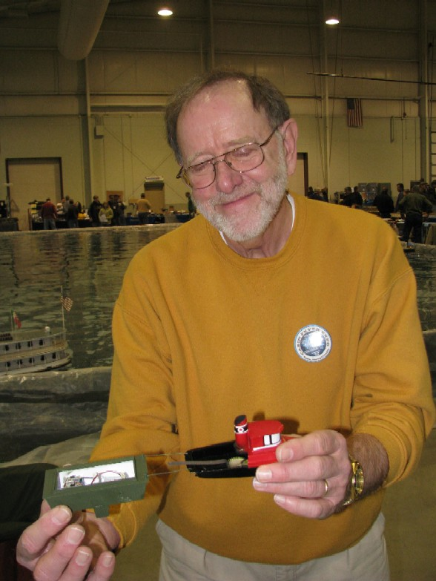

Rich likes making unusual stuff, and he whipped this baby up just before Cabin Fever. He was apologetic as he described it saying that he had only tried it in his kitchen sink. The pictures and video I took were his first trial of the boat in a larger body of water. You have got to watch the video! Listen for the “no wake zone, no wake” cheers from the crowd as this little craft plied the waters! These little guys are easy to swamp in a big tank with lots of model boat traffic.

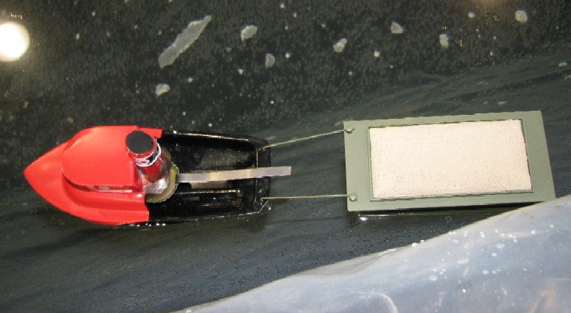

Here’s a photo showing the comparative size of some of the other boats in the tank. Good work Little Toot!

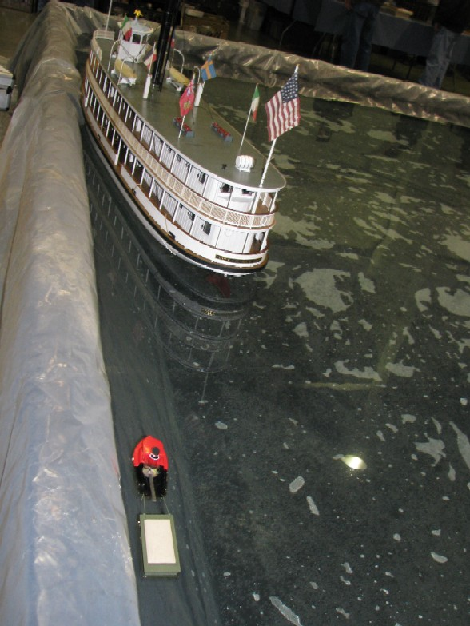

Upon opening the barge I saw the most compact radio-controlled setup I had ever seen, all commercially made and all, Rich swore, inexpensive and very easy to set up. Here in one fell swoop were the ultra light radio control components that many of us small-scale modelers dream of. Best of all, the entire ultra miniature set-up, 3-channel transmitter, receiver, battery, charger, receiver, speed controller, electric motor and servos are available in one package (an ultra-light plane) for under a hundred dollars. The photo below shows the interior of the barge with the twin servos, battery and rudder link. The quarter is shown for scale. As you can see there’s plenty of excess room left within the barge.

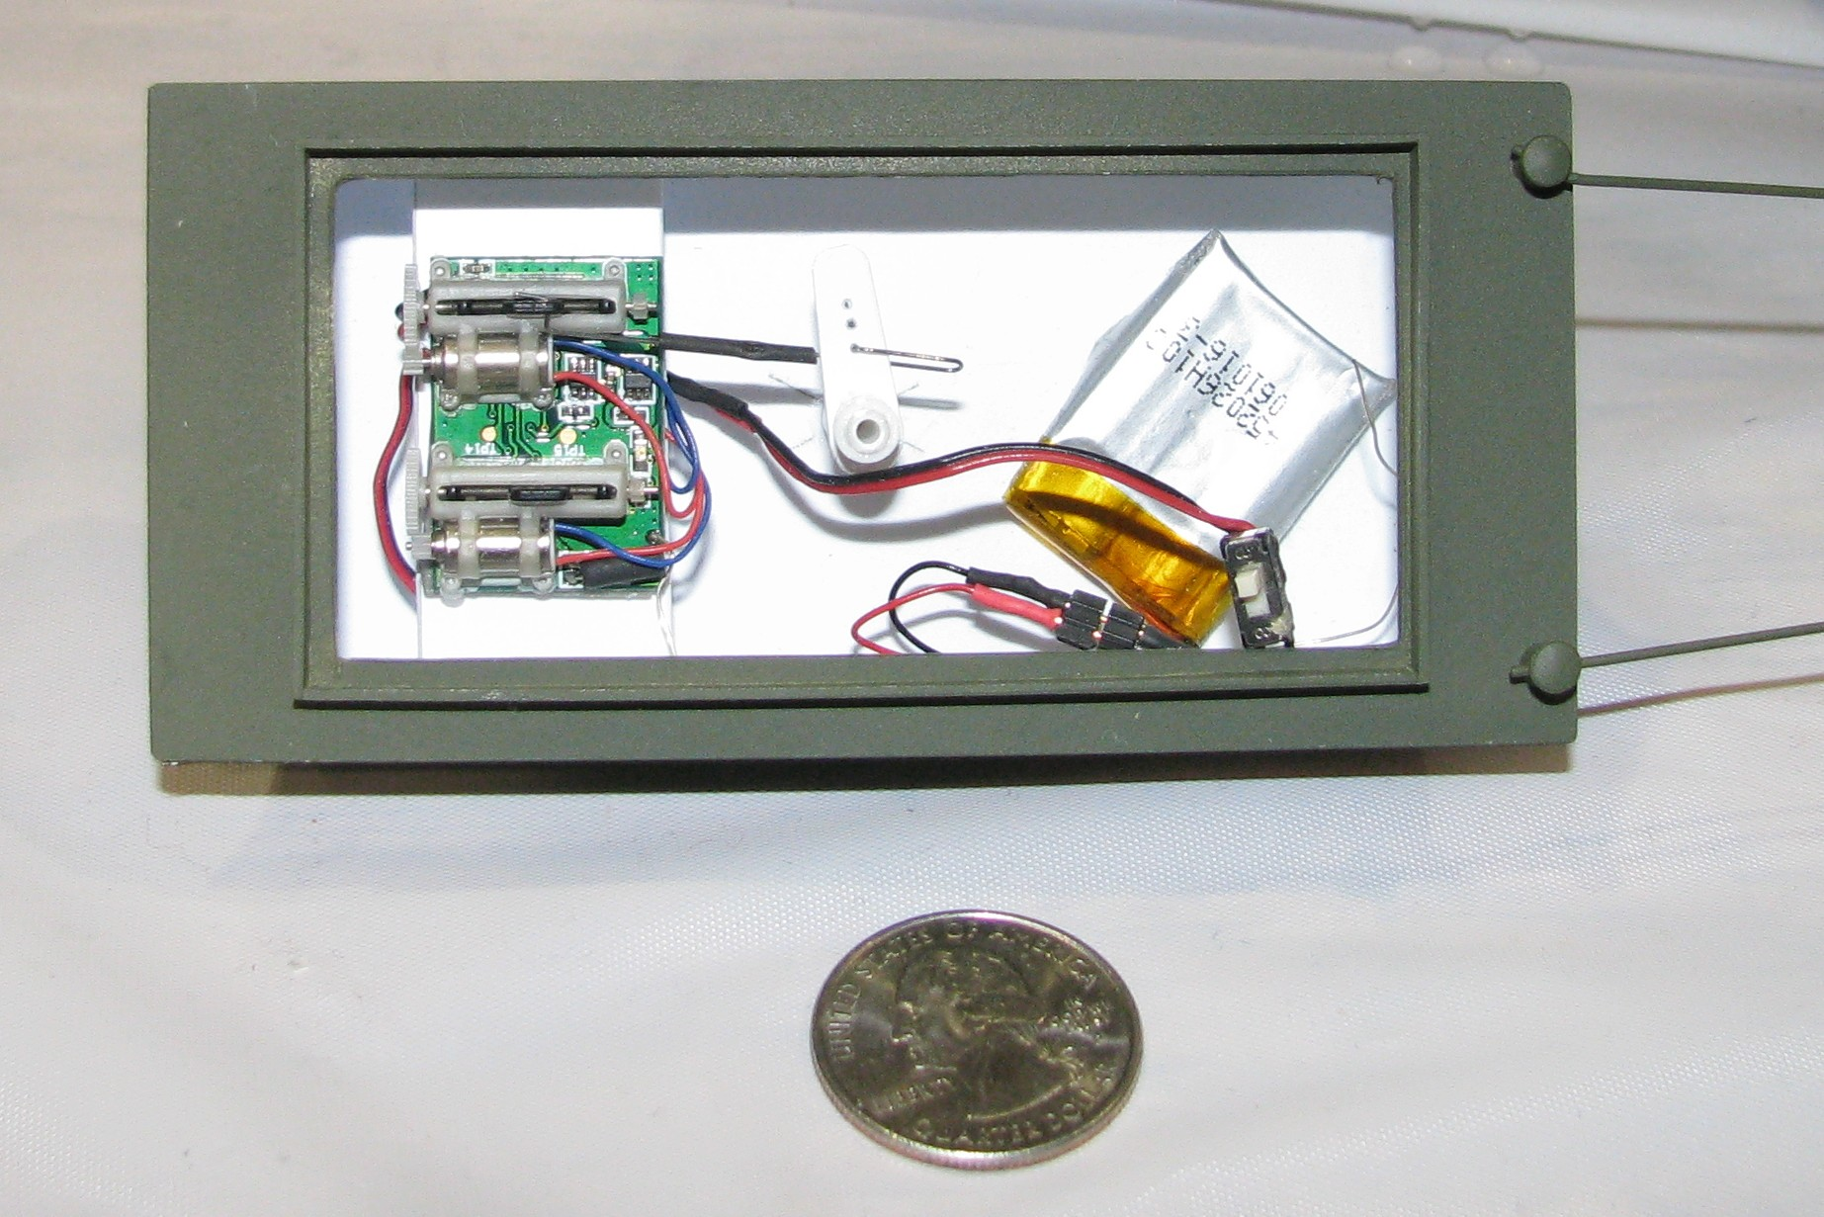

Note that only one of the servos is being used, that engages the rudder. The rotary motion of the servomotor is converted to push-pull by a threaded linear actuator.

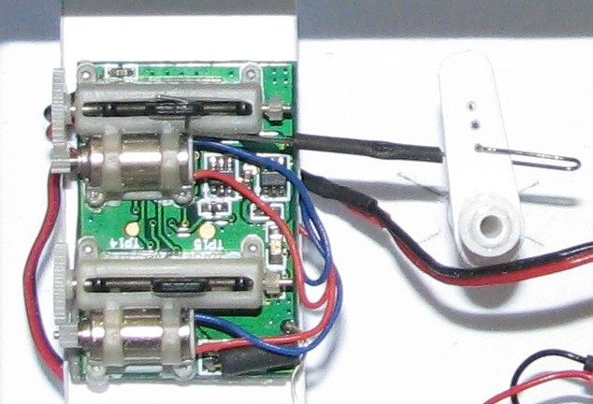

With this particular Indian pop-pop model there is no easy way to regulate speed. Speed can be regulated on a scratch-built pop-pop boat using the second (presently unused) servo, can’t it? Tell us how, boys?

For those that need an explanation of how pop-pop boats work go to my appendix page for Steam Happens 4 at:

http://earlmorse.org/steamboatingpages/steamhappens4/steamhappens4.htm

Perhaps you will get an idea or two on how to control engine output.

Rich provided me with the name of the model and a site on the Web where it can be purchased. You should be able to find a supplier to sell you the package for $100 or less with free shipping:

http://www.hobbyzone.com/rc-planes-parkzone-micro-cessna-210-rtf.htm

While the components can be purchased separately, Rich suggested buying the entire plane kit, flying it for a while, then removing the components for your boat. The kit comes with a 2.4 GHz three channel fully proportional radio, speed control for the motor and servos linked to elevator and rudder. More data and the Owner’s Handbook can be downloaded at the above site. It is well worth perusing. The kit also includes a charger that uses unique circuitry to ensure an accurate charge for the 3.7V 70mAh lithium polymer battery pack. Additional LiPo batteries are $10 each and recharge in 10-15 minutes. The entire plane, fully ready to fly weighs less than two thirds of one ounce (18 grams). Most interestingly, this 2.4 GHz radio technology allows many planes to be used at once without concern for jamming or being jammed by other RC vehicles. No changing crystals, registering your frequency at a meet, wearing frequency flags….nada! Piece of cake. There are lots of videos of this plane in action on YouTube. Here’s one: http://www.youtube.com/watch?v=w_6pgZDs_Yw Just search for Parkzone Micro Cessna. It is truly remarkable how much this micro technology has changed since I first met Rich. Hand-built components have evolved to a mass market, inexpensive technology in less than five years. The proliferation of inexpensive micro-scale planes and helicopters over the last year clearly indicates the growing popularity of this component of the model hobby. As Rich has demonstrated, this micro-miniaturization can become a boon to model steamboaters.

Small steam models place average size radio control components in heat jeopardy. By having micro-scale components you can tuck these parts well away from heat in even the smallest environment, as Rich has demonstrated.

As usual, I have placed additional photos and videos of the micro tug in action on my website. I hope you’ll enjoy them at:

http://earlmorse.org/steamboatingpages/steamhappens16/steamhappens16.htm

If you are a novice to small-scale RC, Rich’s suggestion is a good and easy way to get the stuff together for your first small boat. I hope someone out there gets a chance to design and build a new RC pop-pop. Write an article for Steamboating about your efforts. Meanwhile, get a few kids or grand kids interested in our hobby by helping them build their own boat.

By the way, Rich can be contacted at aeromodeller@yahoo.com

