Steam Happens #20: Donnie's New Steam Canoe – Can You?

Donnie Mains of Limington, Maine is a man with lots of inventive ideas. He's an aircraft inspector and mechanic who likes to build and fly planes. The difference between us is that Donnie's reveries always come to fruition. It may take time and lots of energy, but he's the kind of guy that persists until it's done beautifully and right. He's also had an infatuation with steam as long as he can remember. His great grandfather was a steam captain on Sebago Lake, Maine back in the time when lots of summer visitors moved up the lakes and rivers of Maine by steamboat. I guess he really has steam in his breath.

A couple of years ago Donnie decided to build a steam canoe. These exotic little beasties were fairly popular in England from Victorian times till about the 1920's. They were perfect for wandering the narrow, quiet river backwaters and canals. While a few were made in the U.S, they never achieved the popularity they reached in the U.K.

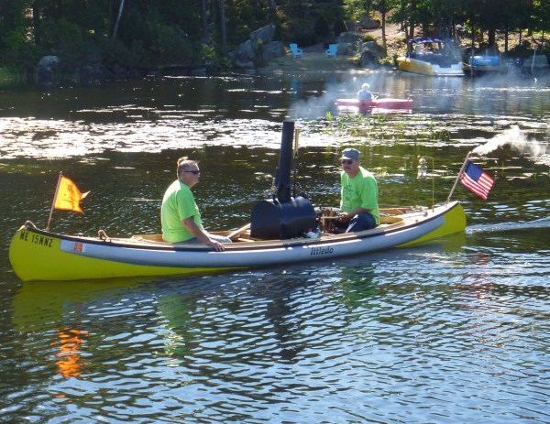
Steam Canoe “Ittledo”

Donnie decided to add to the British character and uniqueness of his vessel by fitting it with a Kitchen rudder. This made it possible to keep his engine simple since a Kitchen rudder eliminates the need for an engine reversing mechanism. The engine and propeller turns only in one direction whether the vessel is headed forward or aft. The rudder was developed by Admiral G.A.Kitchen of Lancashire, England and is designed so that steering, vessel speed and reversing are done by this clever device.

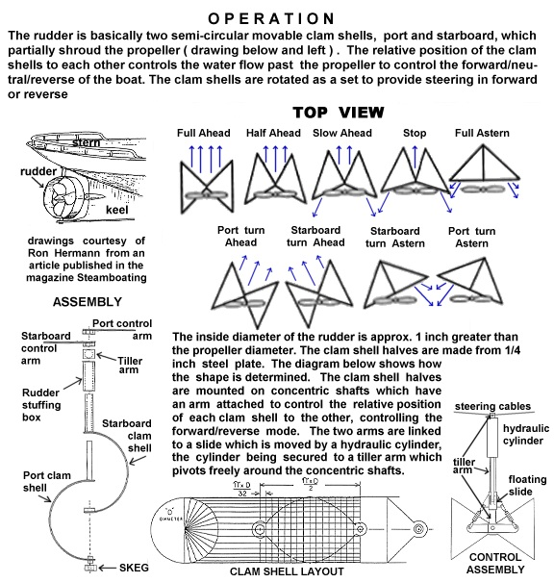

In full-scale boats the Kitchen rudder saw their greatest application in the small, maneuverable motorcraft used by European navies when the internal combustion engine first made its way into marine use. These early I.C. engines were cantankerous devices, hard to start, harder to run smoothly, and not easily reversible. The Kitchen rudder allowed the helmsman to steer, reverse and adjust speed quickly and easily without changing the engine settings or conking out. They were much more maneuverable in tight quarters than the standard rudder. Most boats fitted with these rudders could do a 180 in their own length.

This rudder design is similar to the “clamshell” thrust reverser one sees on some jet aircraft engines. This allows the plane to come to a halt faster than merely using the brakes. These devices redirect the thrust stream of the engine in the opposite direction by closing a pair of “clamshells” into the thrust stream forming a funnel that redirects the exhaust stream forward. The Kitchen rudder does the same and has the added feature of being able to swivel the closed clamshell funnel thus “steering” the reversed thrust stream. In forward operation at full speed the clamshells are fully open forming what appears as a nozzle around the prop. This, too, is totally steerable and in theory it makes the “ahead” thrust stream more rear-directed and efficient, much like a Kort Nozzle.

I have always been infatuated with this rudder design since I saw my first one at a maritime museum in the Netherlands. I've used them in a couple of my model steamboats because they simplify radio control of the boat. This is especially handy when a simple oscillating engine is used with an unregulated boiler fire. I first referred to this design in an article I wrote for Steamboating Magazine describing the usefulness of “Google books” as an instant steam engineering research tool (“Steam Happens # 15: An Instant Steam Library,” Jan-Feb 2009, pp. 15-21).

Here's a couple of close-ups I made during installation of a Kitchen rudder in one of my model boats.

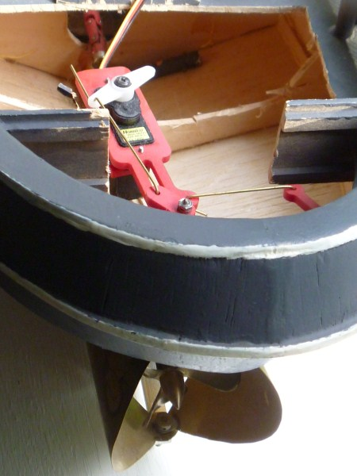
Note that the servo used to actuate the clamshells is carried in the plastic tiller bar. The steering servo is not yet installed.

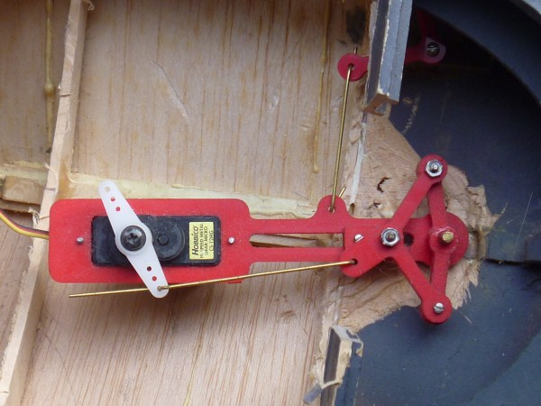

Getting back to Donnie's project. He decided to use a 20 foot old Oldtown children's camp or “war” canoe that he had hanging from the rafters of his barn. This design is especially nice for a steam canoe because it has resilient foam floatation bumpers alongsides to help with roll stability. The canoe was stripped down to its wood, repaired and “recanvassed” using aircraft materials. A prop shaft,log, and stuffing box was added along with engine and boiler supports. Then the Kitchen rudder assembly was installed and the stern faired to improve water flow. The entire boat was brought up to a standard of appearance it had never seen. A three blade left hand propeller was used and the clamshells sized to shroud the prop.

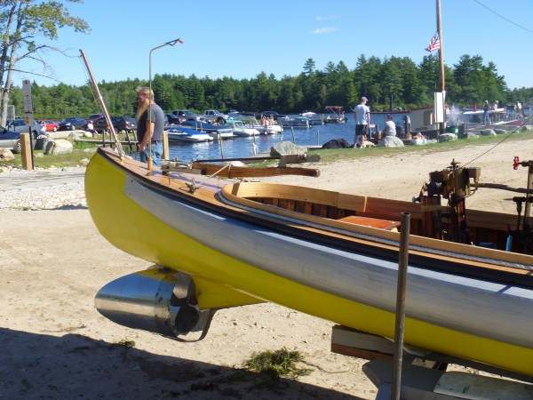
The clamshells below are in the open position.

The photo below shows the clamshells fully closed and right of center. This would be pulling the stern around rightwards in reversed in operation.

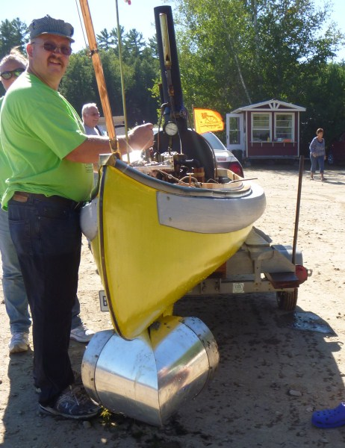

This next photo shows the reversing lever being engaged under way.

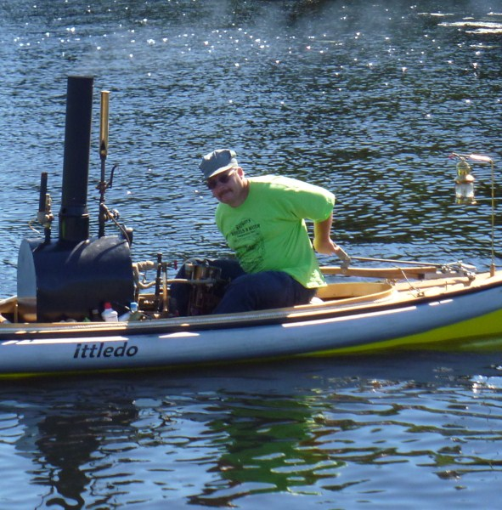

The engine is a small 2 inch bore by 2.5 in stroke vertical mill-type machine that may have been used to power a generator or run a small shop. The maker is unknown. Of course there is no engine reversing mechanism. The boiler is a wood-fired Roberts-type made by Donnie. Note the clever use of the aft flag pole to exhaust steam.

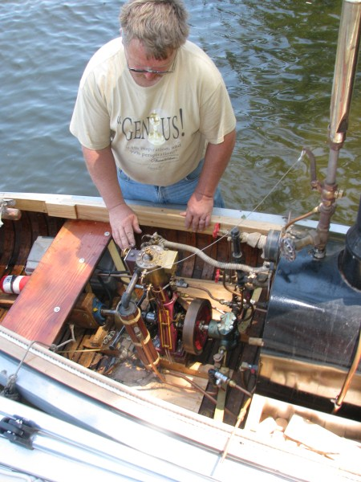

One chronic sickness that all steamboaters have is a constant need to fiddle. Well, it may not be a sickness, but it certainly isn't a wellness! No one is ever satisfied with their boat. Donnie is a perfectionist and a meticulous worker. As such, like all of us, he is not perfectly happy with his vessel. This boat runs well, but my guess is that Donnie will be tweaking the Kitchen rudder design for years to come. Oh well, it keeps him out of the pool rooms.

If you check out the pictures and videos on my website at www.earlmorse.org/steamboa.html you'll see higher resolution photos and videos of Kitchen rudder equipped boats in operation. The following websites show videos of three kitchen rudders operating in model boats. You can view movies of Kitchen rudders in model boats on YouTube at http://www.youtube.com/watch?v=AJKx1wnQnVU and http://www.youtube.com/watch?v=vJjP0rLonlM&NR=1

Most of Donnie's dissatisfaction on the day these photos were taken at the Lee's Mills annual meet came from the proliferation of Eurasian Milfoil, an invasive species of waterplant. Over the years Lake Winnipesaukee in NH has become infested. The next picture shows the plants lying within a foot of the surface in about 7 feet of water. Many boats had fouled props this year, including Donnie's. He kept commenting on the lack of performance on this day and when we pulled the boat onto the trailer the prop and clamshells had accumulated about 5 pounds of plants. Lakes in New England are quickly becoming overwhelmed by invasive milfoils and hydrilla, both of which are being transferred to uninfested lakes primarily by plant fragments on boats and trailers. Always inspect your boat closely after you haul it out of the water and before you enter a new body of water. Look in the water behind Donnie in the photo below to get an idea of the magnitude of the infestation in Lake Winnipesaukee . There's about 7 feet of depth under the stern, yet this tangle of growth comes to within 10 inches of the surface.

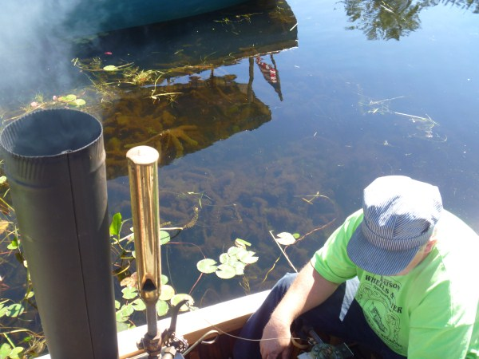
In the photos of the canoe on the trailer you can see some of the plant material we removed from the prop and rudder. Please actively support your local efforts to keep invasive organisms out of your home waters.
