A Maine Congress of Lake Associations raffle offering.
Go to www.mainecola.org to buy tickets for this and other raffle items:
ITEM 2
"up the Kriek without a paddle"
AN ADVENTURE ON A TRADITIONAL MAINE LAKES STEAMBOAT
with a Belgian Twist FOR YOU AND YOUR COMPANION
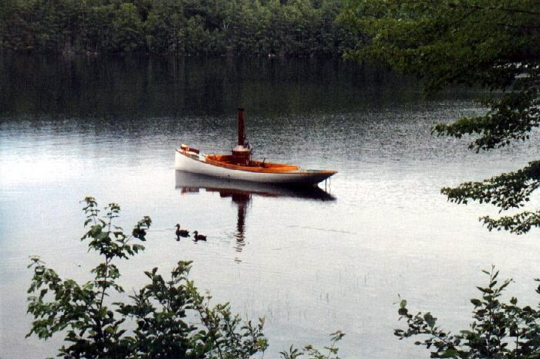
EARL & JOANNE MORSE OF WATERFORD, MAINE
ARE OFFERING
THE EVENING BEFORE:
1. AN ADVENTURE IN BELGIAN DINING COMPLETE WITH OLD LAMBIC AND KRIEK
2. EVENING CHAT ABOUT LOCAL STEAMBOAT HISTORY AND TECHNOLOGY
3. AN OVERNIGHT STAY SO THAT WE MAY HAVE AN EARLY BOATING START
THE NEXT MORNING:
4. COFFEE AND CROISSANTS
5. FOURS HOURS OF HANDS-ON INSTRUCTION ON SL "A BOY'S WILL"
WHERE YOU WILL OPERATE THE WOOD-FIRED BOILER AND ENGINE
AND YOUR COMPANION WILL BE AT THE HELM
(ALL FUEL IS GROWN ON OUR PROPERTY WITH ASH RECYCLED INTO GARDEN AND FOREST VIA COMPOST)
Value: $500

