A Maine Congress of Lake Associations raffle offering.
Go to www.mainecola.org to buy tickets for this and other raffle items:
ITEM 4
INNISFREE
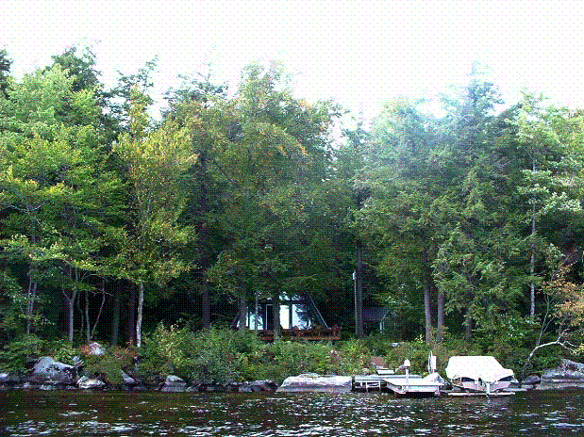
Luxuriate for 3 days in 2 lakeside cabins with direct access and spectacular views of the real Golden Pond! Cabins sleep 6, have kitchen and kitchenette, sun deck, swimming/boat dock, grill. Use of a kayak and canoe included . Great wildlife viewing. VALUE: $600.00



