A Maine Congress of Lake Associations raffle offering.
Go to www.mainecola.org to buy tickets for this and other raffle items:
ITEM 1
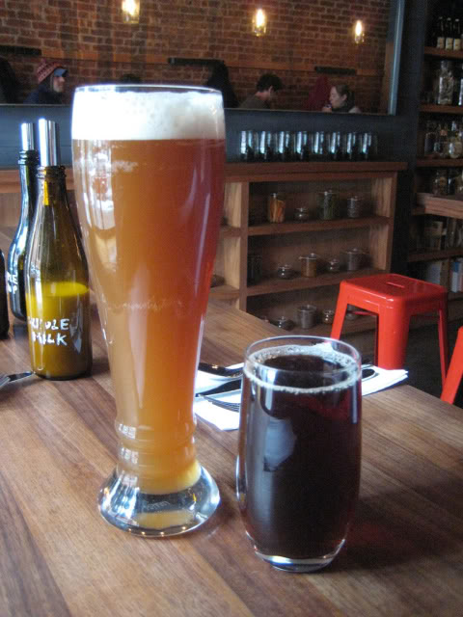
Two six packs of craft-brewed beer
One six pack of Grandpa Pete’s McGaffey Mountain Doppelbock. Named for the highest point in the Kennebec Highlands, this strong (~9% alcohol) dark Bavarian style lager is rich and malty with toasty aromas. This beer is for serious beer drinkers who enjoy a heartier than normal brew. Doppelbocks were traditionally drunk by Bavarian monks as their only food while they fasted during lent. They called their beer “liquid bread.”
One six pack of Grandpa Pete’s Long Pond Lager . Named for the Belgrade Lake with the highest water quality, this beer is brewed using water from a well on the shore of Long Pond. A full-bodied lager similar to Sam Adams Lager, this beer will evoke fond memories of time spent on Maine lakes. Perfect after a successful fishing trip on your favorite lake.
Brewer’s Note: Like fine wine, this beer contains no preservatives, should be treated with care and not exposed to high temperatures or bright lights during storage. It is ready to drink now and should be consumed relatively promptly. Like fine wine, it should be drunk from a glass and not the bottle. There is a bit of brewer’s yeast in the bottom of the bottle so you should decant the bottle by carefully pouring it into a tilted glass to maximize the flavor and aroma. The yeast contains Vitamin B-12 and is probably the healthiest part of the beer but has a distinct yeast flavor that some people don’t enjoy. I hope you enjoy this beer.
Grandpa Pete, Brewmaster Value established in previous auction at $140

